Princess Sumaya University for Technology

King Abdullah II Faculty of Engineering

Electrical Engineering Department



|  |
| --- |
| **microprocessor and embedded systems (22442)**  **final project report**  **Egg Drawing Machine** |

|  |  |  |
| --- | --- | --- |
| ***Authors:*** |  | ***Supervisor:*** |
| Joud Hamdan  Eman Odeh  Dareen Abdelhafez | 20170228  20170282  20180755 | Dr. Belal Sababha |

*January 23, 2023*

**Abstract**

In this report we made an egg drawing machine using one stepper motor with one servo motor interfacing with pic16f877a.

When we turn on the supply the stepper motor will start moving continuously and the servo motor will slide down and put the pen on the egg and start drawing circle around the egg, after finish drawing so the servo motor will slide up the pen.

**Introduction and background**

We will creating an art robot called the EggBot, which is capable of drawing on small spheres and eggs. The EggBot was first invented by motion control artist Bruce Shapiro in 1990. Since then, it has been used in workshops as both an educational tool and a creative medium. In 2010, Bruce and our team began working together on designing and manufacturing EggBot kits.

In our project the machine should draw a circle around the egg using stepper motor and servo motor, when we power on the supply the stepper motor will begin to move and the servo motor will slide down the pen and draw circle around the egg. After the time delay the servo motor will slide up and remove the pen from the egg.

**Servo motor**

Is a type of motor that is used for precise control of angular position. It typically consists of a motor, gear train, and feedback control circuit. The feedback control circuit compares the actual position of the motor shaft with the desired position, and adjusts the motor's power accordingly. This allows for precise control of the motor's position and speed. Servo motors are commonly used in applications such as robotics, industrial automation, and control systems. They are available in a wide range of sizes and power levels to suit different applications. [1]

In our project, we utilize the widely-used SG90 servo motor. This servo motor is a DC motor that is capable of achieving a full range of motion from 0 to 180 degrees. The SG90 servo motor is controlled via a pulse width modulation (PWM) signal, with a typical pulse duration of 20 milliseconds. A 1.5ms pulse width corresponds to a 90-degree rotation of the motor shaft. The angle of rotation is determined by the duration of the electrical pulse applied to the control pin, which is modulated by a variable resistor and a gear train to achieve precise angular positioning. This functionality makes the SG90 servo motor an ideal choice for applications requiring precise control of angular position, such as robotics and industrial automation systems. [1]

**Stepper motors**

It convert electrical pulses into precise mechanical movements by stepping the rotor through a set angle, typically 1.8 degrees per step. This results in 200 steps per revolution of the motor. They can be divided into full-step and half-step types, depending on the number of steps the rotor takes to complete a full rotation. The most commonly used type of stepper motor is the permanent magnet stepper motor, which typically has 200 steps per revolution. [2]

Stepper motors are widely used in precision-oriented applications such as CNC machines, robotics and printing equipment due to their high precision and accuracy in positioning. They are also commonly used in applications requiring low speed and high torque, as well as in situations where the rotor's position must be known at all times, it is controlled through stepper drivers, which send electrical pulses to the motor's coils, generating the appropriate current and voltage, and also provide control signals to step the motor in the desired direction and at the desired step rate.

**Design**

**Mechanical design:**

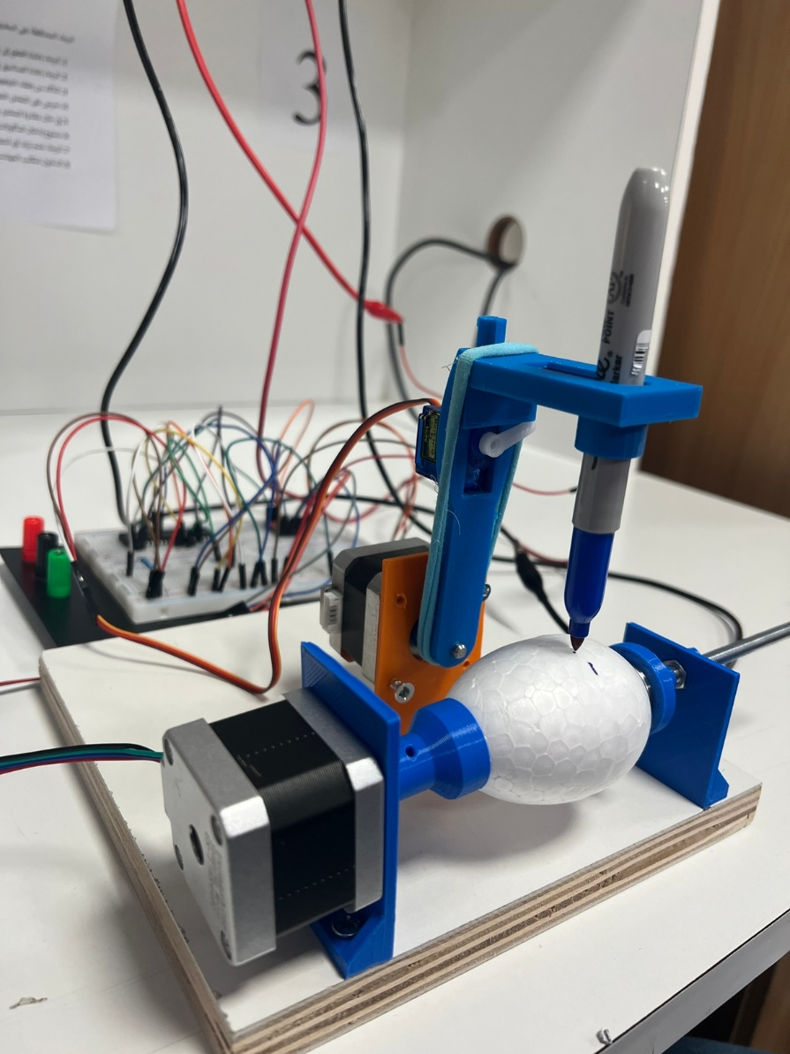

**Figure 1 egg drawing machine**

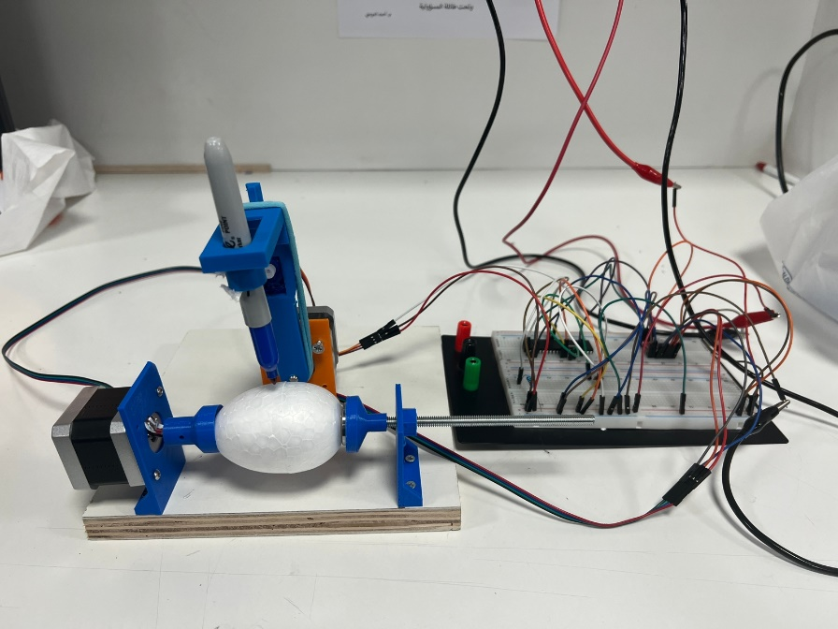

**Figure 2 egg drawing machine with connections**

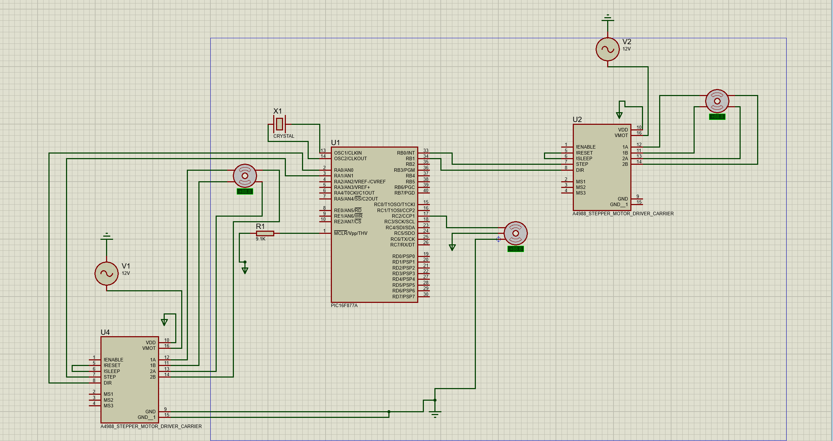**Electrical design**

**Figure 3 egg drawing machine proteus connection**

**Software design**

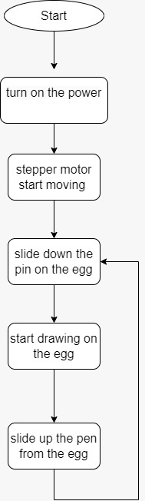

**Figure 4 egg drawing machine flowchart**

**Problems and recommendations**

We faced many problems in our project and try to fix it.

1. Stepper motor was moves one step and stop.

We want it to move continuously so to make it infinite move we used loop in the code like while loop, and put the delay

1. Servo motor was not working on the green kit.

Because we was used oscillator 20 MHz, so we change it to 8 MHz.

1. The servo motor was working on the green kit and not working when we connected on the breadboard.

So we solve this problem by put the master clear of the pic16f877a on the VCC instead of the ground and 10k ohm resister to avoid burn the pic, additionally we put 2 capacitors.

1. USB to TTL.

We try to use the USB to TTL in our project to write sentence by press on the led and the sentence (Egg drawing machine) will appear on the screen of the computer.

But when we used it, it destroyed our USB plug on the laptop

**Conclusion**

Using the knowledge obtained through course, and after acquiring the needed technique and aspects of embedded systems and how to design them, our aim was to develop a machine, drawing on the egg by move the stepper motor continuously and the servo motor slide down and draw on the egg then slide up after finish drawing.

This project we can develop it to help factories, like print the production date on the egg.

**References**

[1] [The Purpose of Servo Motors | Fuji Electric Product Column | Fuji Electric Global](https://www.fujielectric.com/products/column/servo/servo_01.html)

[2] [Stepper Motors: Types, Uses and Working Principle | Article | MPS (monolithicpower.com)](https://www.monolithicpower.com/en/stepper-motors-basics-types-uses)

PSUT Elearning using chapter 8 and 9.